ASSIGNMENT 8:

## TITLE: Converters

PRN: 22510034 Date:11-12-23

Aim:

a. Determine 1’s complement and 2’s complement of any 8-bit number

b. Determine 1’s complement and 2’s complement of any 16-bit number

Software used: GNU 8085 Simulator

Hardware used: DYNA 8085 kit

Procedure:

-Install and open the GNU 8085 Simulator on the computer device, Create and Open the new project and name it as Converters.

-Write the assembly language program according to the question and Assemble and Run it.

-Perform the similar operations on DYNA 8085 kit.

Result:

1. 8-bit number:

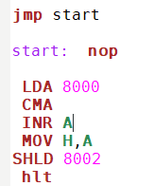

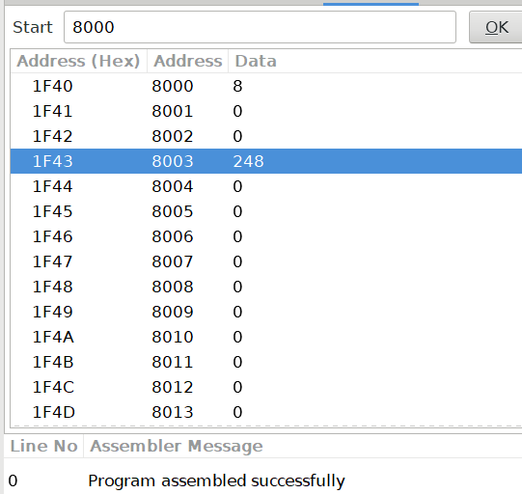

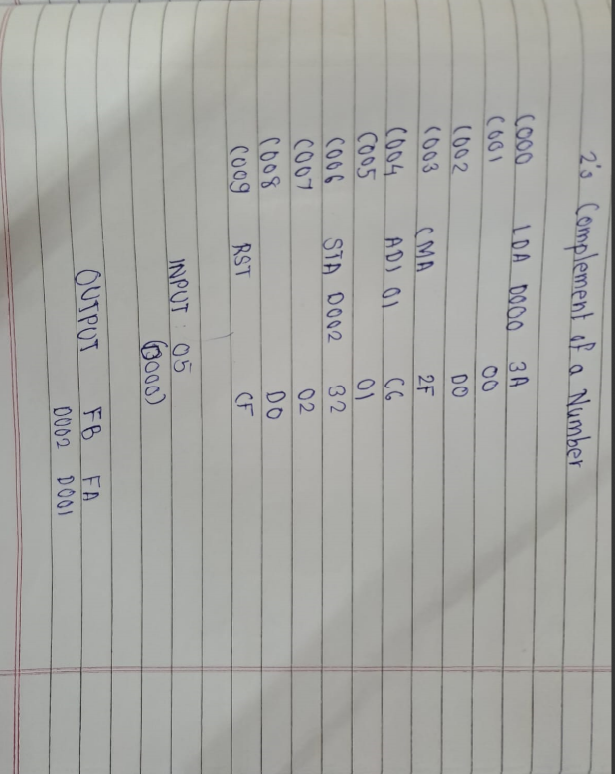

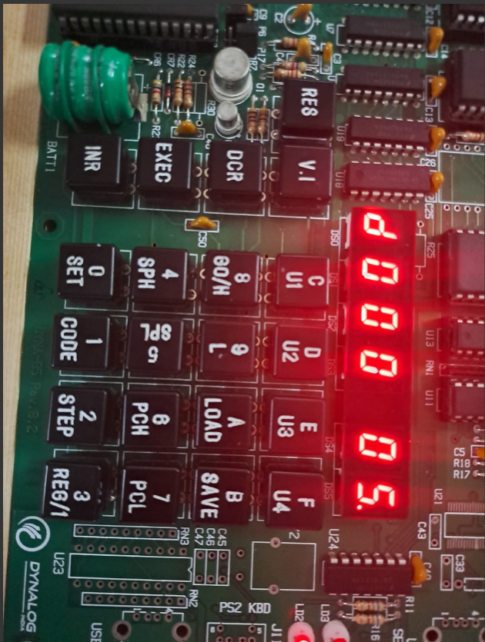

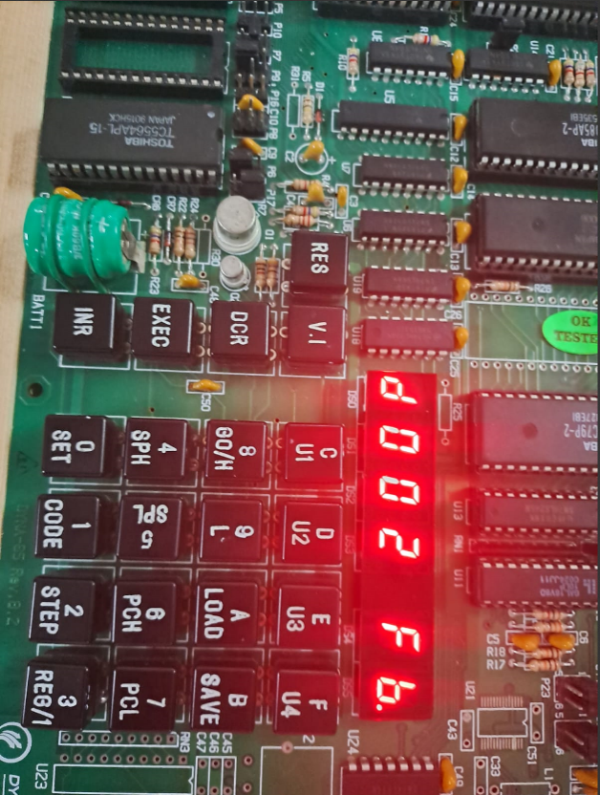

2.16-Bit Number:

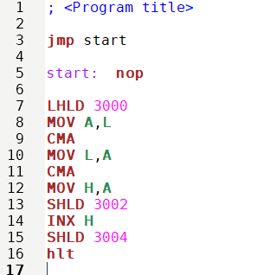

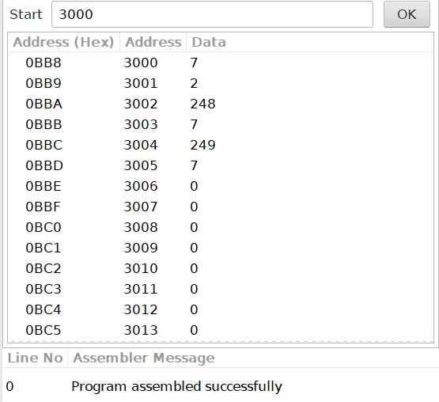

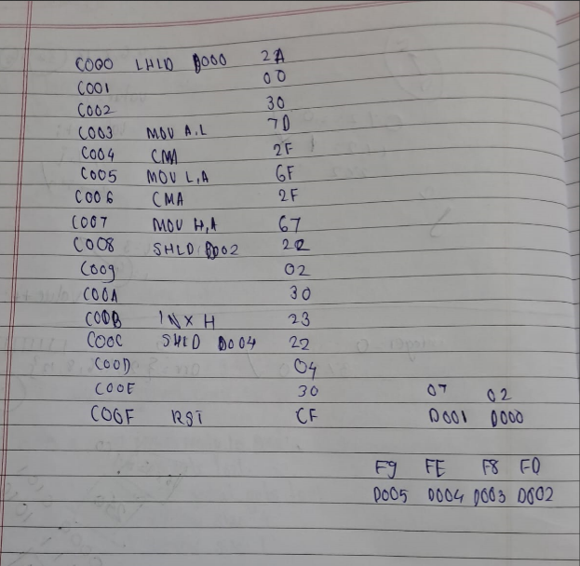

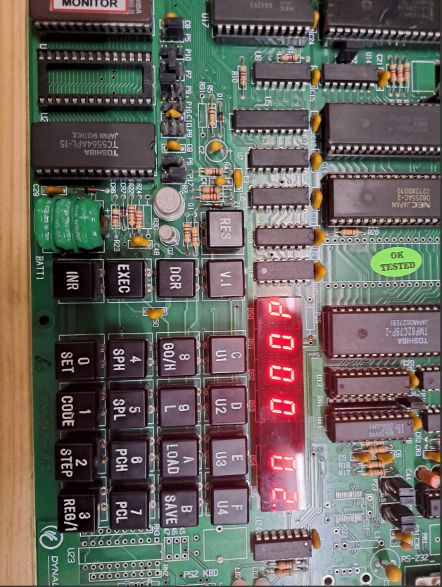

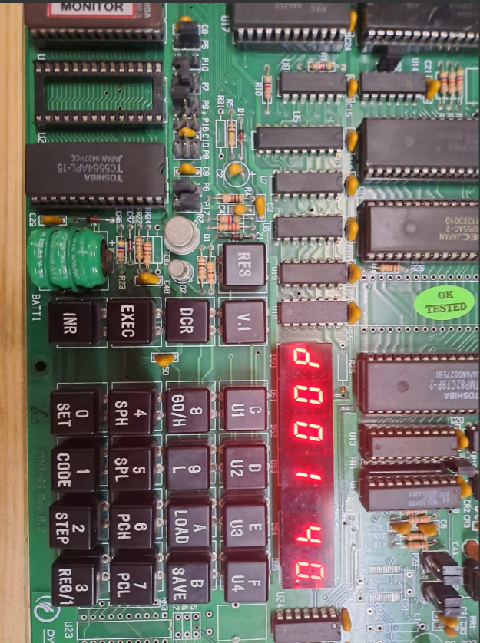

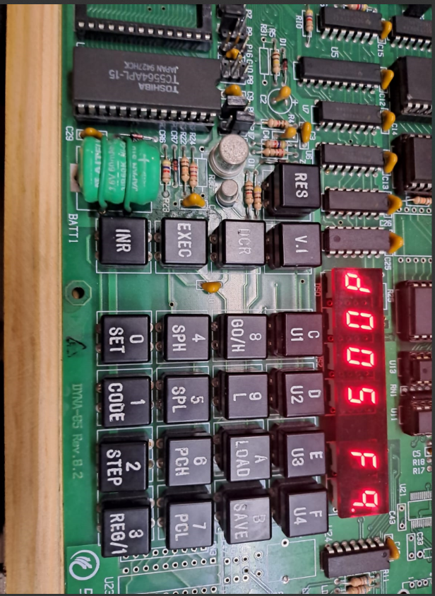

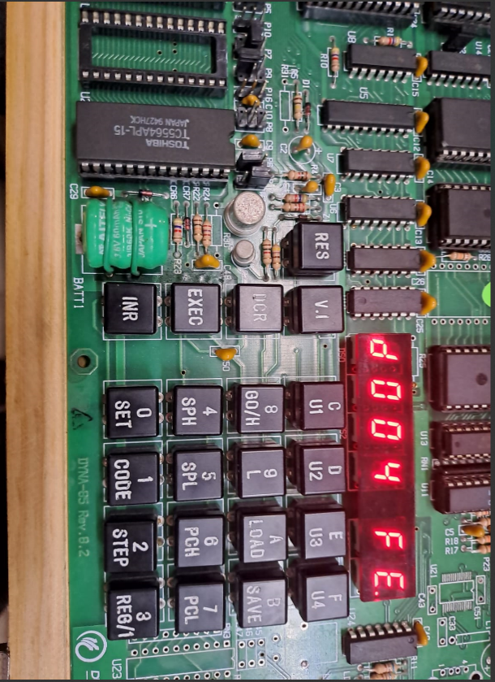

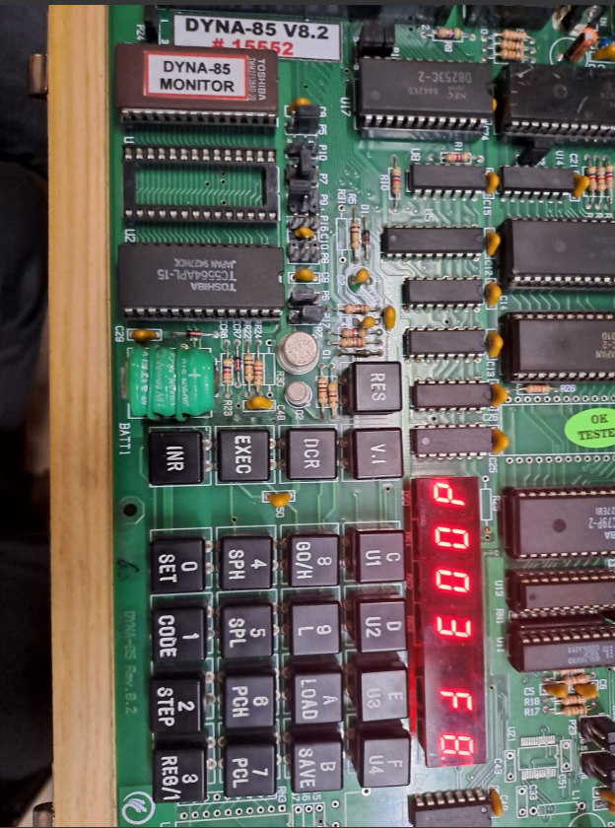 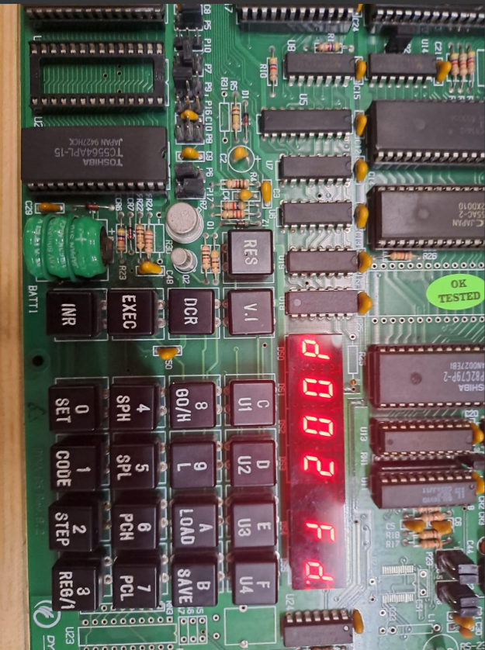

Conclusion:  
Successfully found out 1’s and 2’s complement on GNU 8085 and on DYNA 8085 Kit.